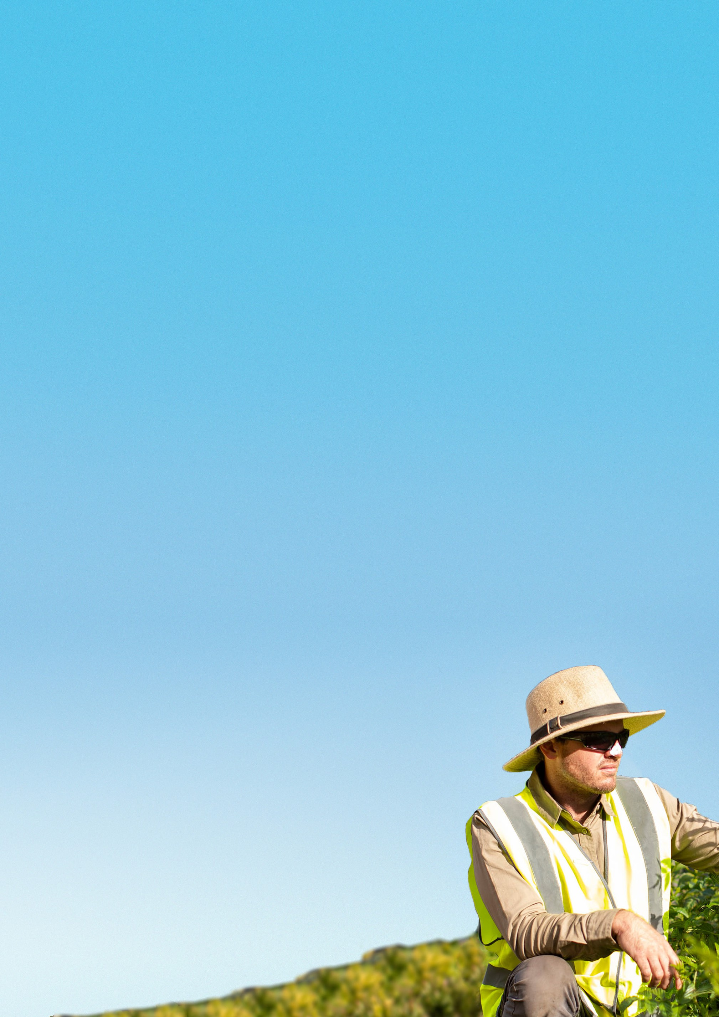


SunSmart Workplace: UV Risk Assessment

Outdoor workers are at high risk of developing skin cancer because they are exposed to up to10 times more UV radiation from the sun than indoor workers.1

On average outdoor workers spend at least 12 hours per week exposed to direct sunlight while at work.² Exposure is cumulative, so each time workers are exposed they are increasing their risk of skin cancer. Print and fill out this UV Risk Assessment and calculate your level of risk.

This solar UV Risk Assessment is designed to help you determine:
- The activities or tasks with the greatest risk of solar UV radiation is in your workplace,
- what sun safety control measures are currently in place,
- the most important priority areas to guide your Action Plan.

This solar UV Risk Assessment is intended to help you
assess the UV radiation risks present in your workplace.
Use this document in combination with the Sun Safe Policy template and the Sun Safety Action Plan.

Tips for completing the UV Risk Assessment:

Consider if you will be assessing one or multiple worksites or job types.
  - If assessing multiple worksites with similar environments and practices, you can complete one overall assessment. Alternatively, you can complete one assessment per site (you may like to print one for each team leader).
  - If assessing multiple job types, consider grouping those workers with similar patterns of outdoor work.

Ensure organisational buy-in.
  - Involve your WH&S representative in the assessment.
  - Consult with a cross section of workers to learn about their needs, opinions and attitudes towards sun safety and the risks they may face. It’s important to know what’s happening on the ground.
  - Use these insights to guide your understanding of the risks.

To learn more about UV radiation and workplaces, refer to:
Skin cancer and outdoor work. A work health and safety guide.

Consider how addressing some UV radiation risks can also reduce the risk of heat stress.
^{1.} Gies P, Wright J. Measured solar ultraviolet radiation exposures of outdoor workers in Queensland in the building and construction industry. Photochemistry and Photobiology. 2003;78(4):342-8.
^{2.} SafeWork Australia. National Hazard Exposure Worker Surveillance: Exposure to direct sunlight and provision of sun exposure controls in
Australian Workplaces. SafeWork Australia. 2010.

Identify which factors or tasks pose the greatest solar UV radiation risks in your workplace
SITE AESSESMENT DETAILS
Single site 
Multiple sites 
Name of site(s):
Job title(s) assessed:
Assessed by: Date: / /
WH&S representative involvement?  Yes  No
If yes, WH&S representative name
Tick the most relevant box to assess your workplace against UV radiation risk.
  - These factors are known to contribute to the amount of UV workers are exposed to.
  - Some factors contribute more than others, which is emphasised by the points* allocated.
  - Some factors may need more than one box ticked. In this case, use the box with the highest points in your subtotals.
Add up each subtotal for environmental, work system and hazardous factors. Once completed, you will have an understanding of the level of risk for each factor, as well an overall level of risk in your workplace. *Points sourced and adapted with approval from Sun Safety at Work Canada: UV risk assessment: operational review.

ENVIRONMENTAL FACTORS

How much time is spent in the sun (including in vehicles without window tinting): UV radiation is highest in middle of the day and during summer months.

 All day | 25 | Severe
 10am-3pm | 20 | Very high
 3-5pm | 15 | High
 8am-10am | 15 | High
 After 5pm | 5 | Moderate
 Before 8am | 5 | Low
 At night | 0 | Nil

Season when work takes place: In large parts of Australia UV radiation is high enough to damage unprotected skin at least 10 months of the year.

 All year | 50 | Severe
 Summer | 40 | Very high
 Autumn/spring | 20 | High
 Winter | 10 | Moderate
Altitude of worksite: Higher altitudes have a higher UV rating than lower altitudes. Check the SunSmart App for the UV in your area.

 More than 1500m  (e.g. Mt Hotham , Perisher*) | 10 | Very high
 1000-1500m  (e.g. Reynolds Neck, Katoomba*) | 8 | High
 500-1000m  (e.g. Armidale, Bathurst*) | 6 | High
 Less than 500m  (e.g. Brisbane, Kalgoorie*) | 2 | Moderate
Latitude: Locations closer to the equator have higher UV radiation levels.

 QLD, NT, mid-north WA | 12 | Severe
 Mid-North NSW, SA | 10 | Very high
 VIC, Mid-South WA | 8 | High
 TAS | 4 | Moderate
* Locations are indicative only. UV radiation is affected by several factors
including geographic location, time of day and cloud cover.

Environmental factors subtotal
Workplace subtotal | Score | Risk rating
 | >24 | Severe
 | 21-24 | Very high
 | 18-20 | High
 | <18 | Moderate

WORK SYSTEM FACTORS
Shade during work: Good quality shade can reduce solar UV radiation exposure by up to 75% and reduce heat stress.

 No shade | 20 | Severe
 Partial shade | 10 | High
 Total shade | 5 | Moderate

Shade at rest breaks: Providing shaded areas for rest breaks is important to minimise the effectsof solarUV radiation, heat and rain.

Sunburn from work activities: Sunburn can take 24 hours to show. The more frequent and severe the sunburn, the higher the risk of skin cancer. It also reduces the body’s ability to cool, increasing heat stress risk.

 Regular occurrence | 25 | Severe
 Irregular occurrence | 10 | Moderate
 No occurrence | 0 | Nil
Work system factors subtotal
Workplace subtotal | Score | Risk rating
 | >19 | Severe
 | 13-19 | Very high
 | 6-12 | High
 | <6 | Moderate

 No shade | 20 | Very high
 Partial shade | 5 | High
 Total shade | 2 | Moderate
 Indoor break area | 0 | Nil

HAZARDOUS FACTORS
The presence of reflective surfaces or photosensitising substances such as industrial chemicals, drugs, plants, fragrances and some
medications will increase the risks posed by UV radiation.
Reflective surfaces: Most surfaces that reflect glare will also
reflect solar UV radiation, and newer or hard, smooth surfaces will reflect more UV than older and softer ones.
Photosensitising substances: industrial chemicals and plants: Certain substances can increase sensitivity to solar UV radiation. The product Safety Data Sheet (SDS) can be used to identify any photosensitising substances.
 Snow, roofing or  cladding iron | 25 | Severe
 Sea surf, white house paint, dry beach sand | 20 | Very high
 Concrete, asphalt, open ocean | 4 | Moderate
 Grass, soil | 2 | Low

 Regular exposure
20 | Severe
1 | High

 Temporary exposure

 No occurrence / not
identified by SDS
0 Nil

Hazardous factors subtotal
Workplace subtotal | Score | Risk rating
 | >24 | Severe
 | 16-24 | Very high
 | 6-15 | High
 | 3-5 | Moderate
 | <3 | Low
Add up your environmental, work system and hazardous factors sub-totals to get your final score.
If your overall workplace risk rating is:
Very high: Your workplace setting presents very high levels of UV exposure, significantly increasing your outdoor workers’ skin cancer risk. As their employer, you have an obligation to provide a safe environment that protects them from harmful UV rays. Use Section 2 below to review your current safety control measures and identify the gaps you could prioritise in your Action Plan.
High: Your workplace conditions present high levels of UV exposure, substantially increasing outdoor worker skin cancer risk. By assessing your current practices below, consider where you can take action on the most protective control measures first to achieve the biggest reduction in skin cancer risk.
Moderate: Your workplace presents a moderate level of risk to your outdoor workers, resulting in cumulative UV radiation damage. Reviewing your control measures and prioritising new methods of protection in your Action Plan can help to make a difference in reducing their skin cancer risk.

Workplace risk scores
Environmental score
Workplace score
Hazardous score
Overall total score

Overall workplace risk rating
Workplace total | Score | Risk rating
 | >69 | Severe
 | 52-68 | Very high
 | 35-51 | High
 | <35 | Moderate

Identify what sun safety control measures are currently in place

UV Radiation Control Measures | Currently practicing | Looking to practice | Not practicing | Not applicable
Policy
A sun safety policy or procedure
Engineering controls
Provide built (portable or fixed) or natural (trees) shade for workers
Provide window tinting in vehicles and mobile plant (e.g. tractors, forklifts)
Administrative controls
Schedule outdoor work tasks outside of peak UV radiation times
Rotate workers between indoor/shaded and outdoor tasks
Modify exposure to reflective surfaces (e.g. move tasks to another location,
provide shade over surface)
Encourage role modelling of sun safety practices by leadership and management teams
Provide sun safety education and training to staff and encourage application of 50+ sunscreen to exposed skin every day to reduce cumulative unplanned exposures
Provide sun safety information and resources to remind staff of workplace
expectations (e.g. place sunscreen in accessible areas, posters)
Minimise exposure to photosensitive substances
Advise workers to consult their GP if they have concerns about their skin or are taking medication that may cause photosensitivity
Include UV protection requirement in procurement procedures (e.g. UPF 50+ uniform fabric and minimum UVE of 95% for shade) and purchase from reputable Australian suppliers
Personal Protective Equipment (PPE)
Provide training on the importance of wearing sun safe PPE and ensure wearing it is mandatory
Provide a broad-brimmed, bucket or legionnaire style hat
Provide attachable brims and neck flaps for hard hats or helmets
Provide shirt with long sleeves and collar made from UPF 50+ fabric
Provide long trousers made from UPF 50+ fabric
Provide uniform that is designed to keep workers cool yet provide maximum sun protection
Provide at least SPF 50+ broad-spectrum, water-resistant sunscreen and lip balm
Provide wrap-around sunglasses that are labeled as complying with (AS/NZS 1067.1:2016) marked ‘o’ for outdoor use

Set your sun safety priorities
CAN26447 01/26
Reflect on the highest scores from Section 1, your existing controls from Section 2 and consider what can be changed in your
workplace. This will help you to identify your priorities for improvement.

EXAMPLE:
If your Risk Assessment indicated challenges with respect to:

PPE non-compliance (like sun safe uniforms or hats):
You might like to consider prioritising policy, administrative controls and PPE that:
- Tighten your policy so that PPE is mandatory.
- Ensure uniforms are specially designed to be lightweight and cool, yet still provide maximum sun protection.
- Reinforce worker expectations by providing education and training, supported by role modelling strategies, and reduce any optional uniform choices that are less sun safe (e.g. cap wearing).

Lack of shade availability:
You might like to consider prioritising policy, engineering and administrative controls to:
- Improve commitment to shade from leadership, accessibility and placement, and encourage its use.
TIP: We strongly recommend you ensure that your workplace UV safety policy is updated as it forms the foundations for all your practical implementation activities.

OUR WORKSITE PRIORITIES ARE (PLEASE TICK ALL THAT APPLY):
 Policy

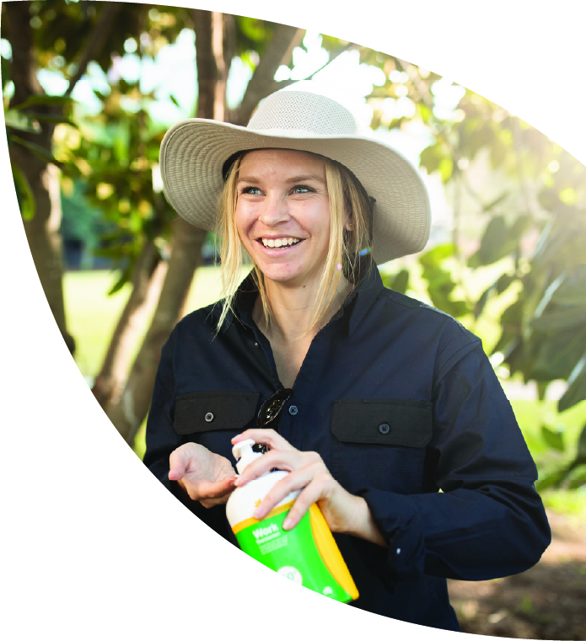
 Engineering controls
 Administrative controls
 PPE
You are now ready to develop your
Action Plan

